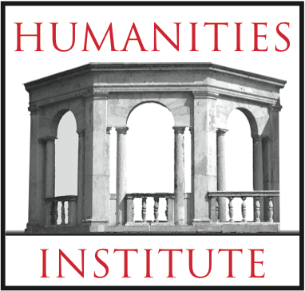
HUMANITIES INSTITUTE

QUICK GRANTS

Humanities Institute “Quick Grants” are independent of the main Program Grants that are awarded in October, February, and August. They are designed to give Humanities Faculty streamlined access to funds of up to $250 for projects that fit within the purview of Humanities Institute Program Grants. As with those more substantive grants, Quick Grant proposals should seek funds for projects that enhance the educational experience of students and/or faculty development through programs, events, initiatives or research in the humanities. The grants do not fund research stipends, equipment purchases (including computer hardware), travel to professional meetings and conferences, or tuition costs for degree programs; however, other forms of research support (such as travel to collections or archives, development workshops, microfilm access, research assistance, etc.) are considered.

Applications may be submitted by any CAS faculty member, and need not be accompanied by a letters of support, ancillary documents, or itemized budgets. Simply complete the form below and submit it via email to Elizabeth Hastings at ehastings@fairfield.edu. For further details regarding the broader aims of Humanities Institute Grants, see the Call for Proposals at https://www.fairfield.edu/media/fairfielduniversitywebsite/documents/academic/hum_callforproposals_6-2016.pdf

Quick Grants will be reviewed on the first of every month during the academic year except for those months in which the main Program Grants are reviewed: September 1, November 1, December 1, January 1, March 1, April 1, May1.

1. Name and Rank of Applicant:

2. Department:

3. Date of Application:

4. Description of proposed use of funds (150-200 words):

